Period tracing for PNF 1M8 model

For FCATR = 21, the 1-par bifurcation with periodic curves are shown below.

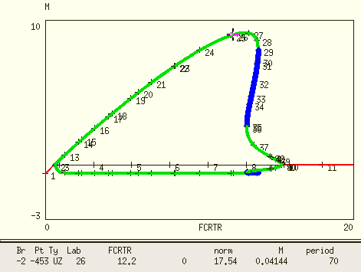

T=70 @ FCRTR=12.2 and FCRTR=13.21

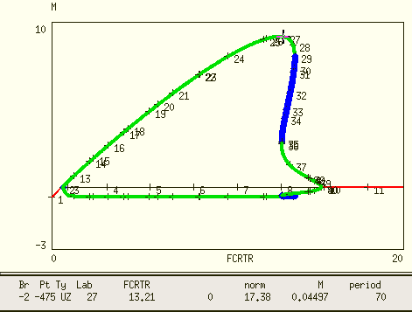

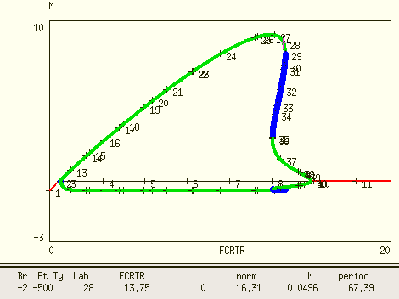

T=67 @ FCRTR=13.75

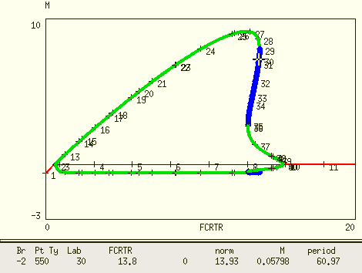

T=60 @ FCRTR=13.8 unstable limit cycle

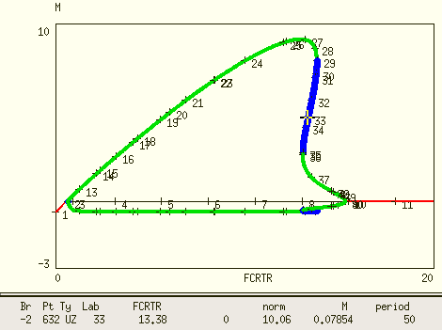

T=50 @ FCRTR=13.38 unstable limit cycle

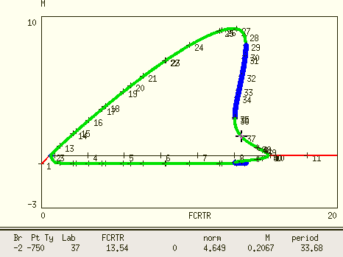

T=33 @ FCRTR=13.54 stable limit cycle

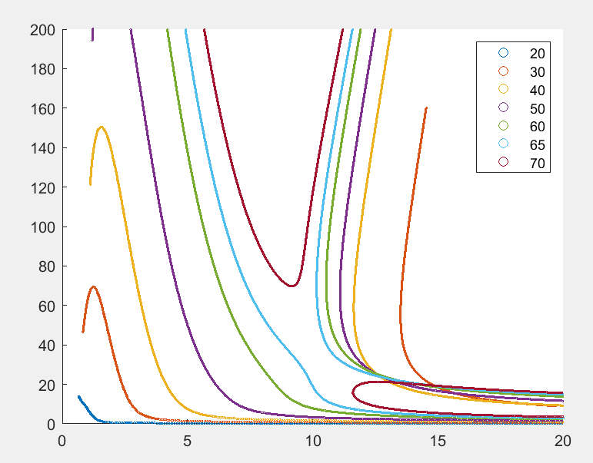

This is the period tracing curve I did for T=20~70. Based on my testing shown above, some part of these curves corresponds to the period of unstable limit cycle or stable limit cycle with small amplitude, which should be discarded.

After I exported the raw data of period tracing, I found that there is no information of stability from Xpp. However, there is information of stability for 1-par bifurcation. Please see my result in the next page.

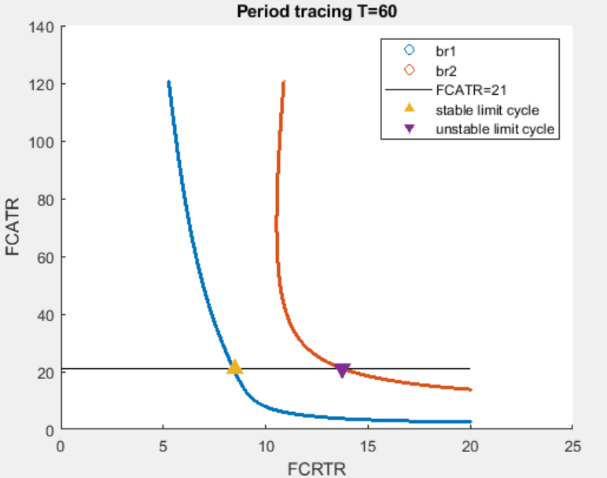

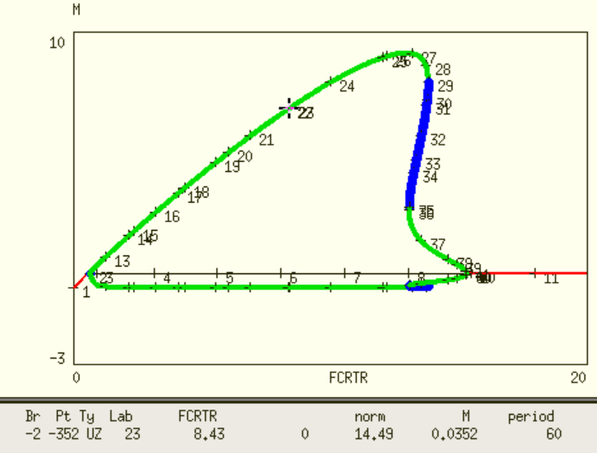

period=60 @ FCRTR=8.43

The Xpp raw data “allinfo” is shown below.

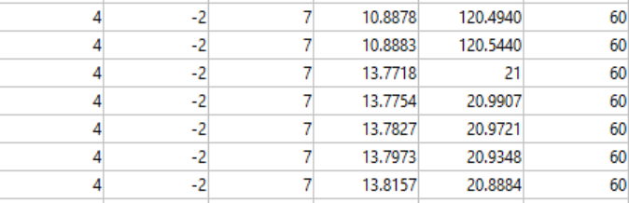

This is from the “allinfo” output dat file, its “type” is 4, “twop” is 7.

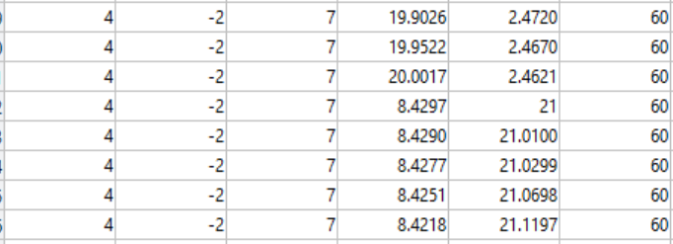

For another point, there is no difference. The “type” is 4,”twop” is 7.

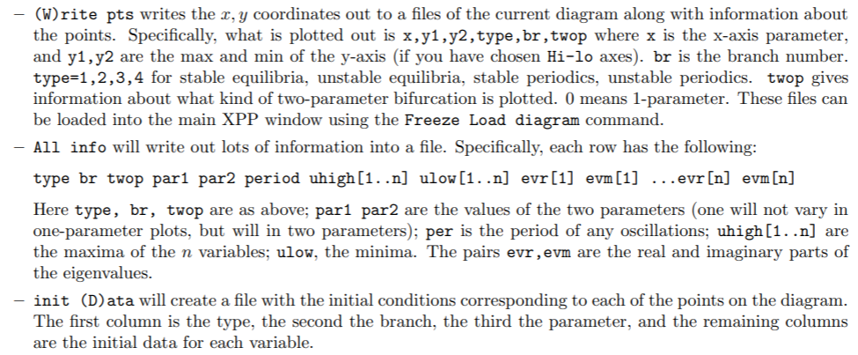

This is from Xpp tutorial webpage.